Midterm Examination Fall 2025

Please submit your midterm Word document no later than 1:30 p.m. on October 21 via the submission link on Blackboard.

First Name: Last Name: UCAID:
Multiple Questions (2 points per question, 60 points in total)
Please review the following questions and ALL answer choices before selecting the BEST answer.
- Which one does NOT belong to 3S technologies?
  - GPS
  - GIS
  - Remote Sensing
  - Computer Science
- What data type is made up of points, lines, and polygons?
  - Vector
  - Raster
  - Relate
  - Geometric network
- ________ is not a standard main element of the map.
  - Title
  - Legend
  - Scale
  - Table
- Conway has a location of 35.01°N and 92.4°W. The 35.01°N and 92.4°W are represented in which coordinate systems? a
  - Geographic coordinate system
  - UTM coordinate system
  - Projected coordinate system
  - State plane coordinate system
- Which one is NOT a developable surface? d
  - Cylinder
  - Cone
  - Plane
  - Sphere
- In conic projection, the longitude is ________ and latitude is ________. a
  - straight, curve
  - straight, straight
  - curve, curve
  - straight, circles
- Mercator project distorts ________ but not ________. b
  - shape, distance
  - size, shape
  - size, distance
  - shape, size
- State Plane coordinate system is most suitable for mapping at_____. a
  - city to county scale
  - global scale
  - continent scale
  - state scale
- Points have a dimension of _____. d
  - 1
  - 2
  - 3
  - 0
- Which one is the vector data format? c
  - .img
  - .tif
  - .shp
  - .png
- Raster data is made up of _____. c
  - Points
  - Lines
  - Pixels
  - Polygons
- In raster data, the 4-bit radiometric resolution represents _____ unique values? c
  - 4
  - 8
  - 16
  - 256
- The cell size of raster data is called _____. b
  - area
  - spatial resolution
  - temporal resolution
  - length
- 23°C temperature is an example of _____ data. c
  - Nominal
  - Ratio
  - Interval
  - ordinal
- In a table or aspatial query, the ‘grater than or qual to’ logical operator is symbolized as _____. d
  - =
  - >
  - <=
  - >=
- In an attribute table, the attribute whose values can uniquely identify a record is called _____. d
  - Field
  - Course Number
  - Name
  - FID
- A feature class is _____. d
  - a property of a geodatabase shared by the individual datasets
  - subsets of features in a table that share the same attribute
  - used to organize the geodatabase
  - collection of features that share the same geometry (points, lines, or polygons) and spatial reference
- To establish a relationship between features, one record in Table 1 related to many records in Table 2 is called _____ relationship. b
  - one-to-one
  - one-to-many
  - many-to-one
  - many-to-many
- In raster data, vegetation map is an example of _____________ data. d
  - continuous
  - overlay
  - vector
  - categorical
- In map projections, several types of distortions can occur. Which of the following is not a type of distortion?
- Distance
- Area
- Direction
- Topology
- A map is a reduced, selective, and _____ graphical representation of the environment. d
  - reprojected
  - flatten
  - spatial
  - symbolized
- The following map is an example of _____. C
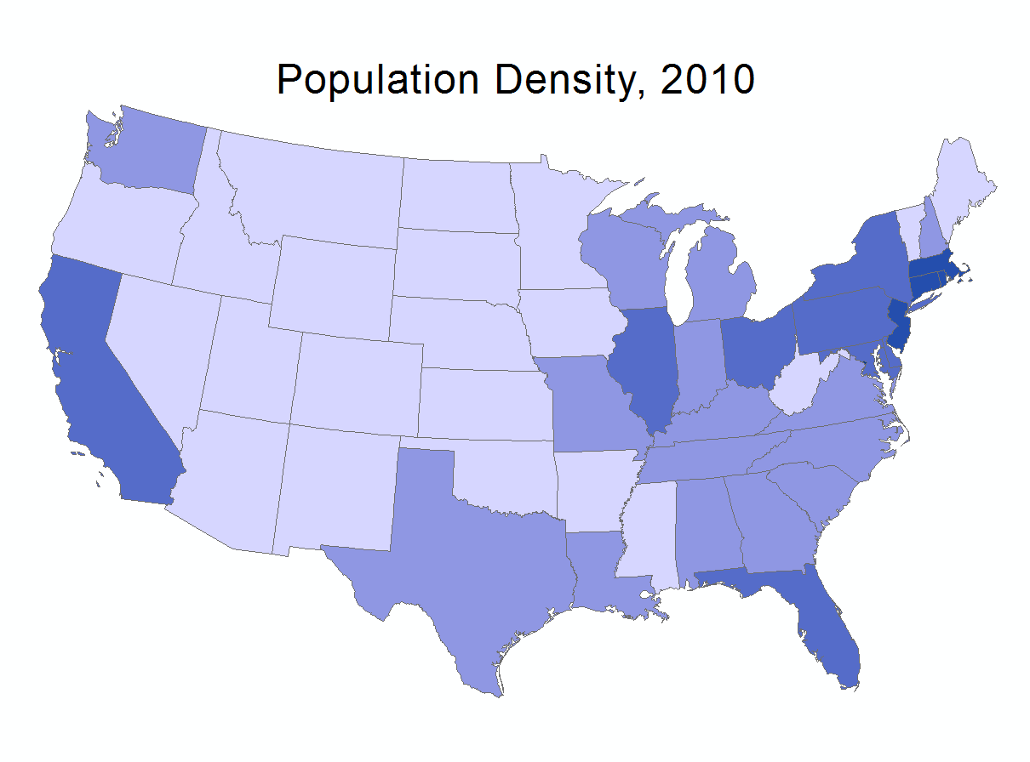
  - mapping proportions
  - mapping relationships between variables
  - mapping density
  - mapping statistic average
- The following map is an example of _____. d
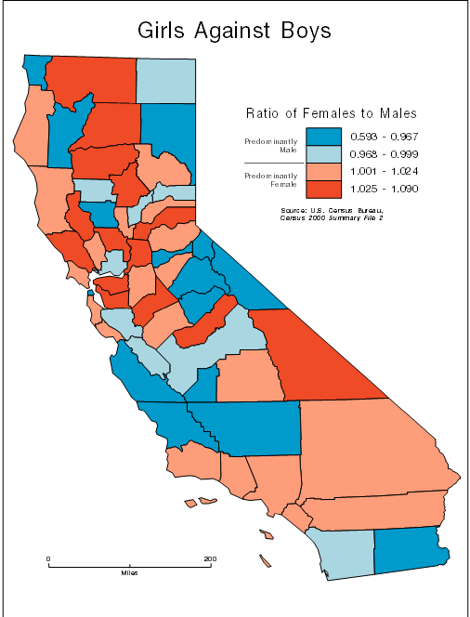
  - mapping density
  - mapping statistic mean
  - mapping proportions
  - mapping relationships between variables
- In which classification method, each class occupies an equal interval along the number line? b
  - Quantile
  - Equal interval
  - Natural breaks
  - Mean-standard deviation
- Which classification does work well with skewed data? d
  - Equal interval
  - Quantile
  - Mean-standard deviation
  - Natural breaks
- One-dimension phenomena can be symbolized as _____. c
  - volumes
  - points
  - lines
  - areas
- In raster data, each cell stores _____: b
a. A coordinate pair
b. A single value representing an attribute
c. A vector feature
d. A color symbol
- Which of the following is not a component of a GIS system _____ ?d
a. Hardware
b. Software
c. Data
d. Weather
- In the attribute table, each row represents _____. c
a. An attribute field
b. A column heading
c. A single feature record
d. The map’s coordinate system
- The Universal Transverse Mercator (UTM) projection divides the Earth into how many zones? _____ b
a. 30
b. 60
c. 120
d. 180
True/ False Questions (2 points per question, 20 points in total)
- Vertical datum is a standardized reference surface used to define elevations and depths on the Earth's surface, serving as a "zero" point for measurements. T
- People is NOT a component of a GIS. F
- GIS is only for map making. F
- Earth is like an oblate spheroid. T
- Map projections allow us to view 2D surface on the 3D Earth. F
- There are no distortions at standard lines. T
- There is a projection that produces no distortions. F
- Azimuthal projections can maintain certain directions over the entire globe. F
- Albers Equal Area projection can be used to map the United States. T
- Topology will be changed when the map is stretching or bending. F
Short Answer Questions (2 points per question, 20 points in total)
- The functions of GIS include capture, store, __query________, _analyze_______, and display.
- Zero longitude is called ____prime meridian_____________.
- Conformal projections preserve local _angles________ and ___shape_______.
- Equivalent projections represent areas in correct relative___size________.
- What types of geometries can be stored in a shapefile _____________.
- In attribute table, the row is called __record______.
- Name the two types of geodatabases supported by ArcGIS _____________.
- What is the file extension for a File Geodatabase _____________.
- The process of grouping numeric data values into ranges or categories is called ________________.
- Name three types of data that can be stored in geodatabase________________
Long Answer Questions (50 points in total) :
- Explain the difference between a geographic coordinate system (GCS) and a projected coordinate system (PCS) (20 points).
- Describe the three mandatory files in a shapefile and explain the function of each file (15 points).
- Discuss the difference between vector and raster data models in GIS (15 points).
Include: a. How each model represents spatial features. B. The types of data or analyses best suited for each

